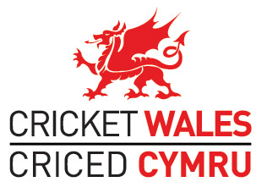

CRICKET WALES CHIEF EXECUTIVE OFFICER – PERSON SPECIFICATION
Background
- Cricket Wales is recruiting for a new CEO to lead the organisation in its first joint strategy with Glamorgan Cricket ‘Inspiring Generations; Yn Ysbridoli Cenedlaethau’.

Person Specification

- The successful candidate will have the following skills and experience:

  - significant leadership and management experience;

  - strong values that resonate with the volunteers and staff working within cricket and thereby consolidates a culture of integrity, innovation, collaboration and learning;

  - a proven track record of successfully leading change that ideally includes the voluntary or charity sector;

  - the ability to forge outstanding relationships with Glamorgan Cricket, the ECB, Sport Wales, NGB’s, Local Authorities and other funding partners;

  - experience of leading organisations towards closer collaboration with others;

  - an understanding of devolution and how it relates to sport;

  - proven experience of developing a strategy and successfully leading individuals and teams in delivering it;

  - Strong negotiating skills and resilience when required;

  - Clear strategic thinking and decision-making;

  - Well developed political antennae enabling Cricket Wales to be optimally positioned;

  - A passion for sport and ideally cricket;

  - Outstanding verbal and written communication skills that inspire others to follow;

  - A good understanding of strategic financial management;

  - Fundraising and/or commercial development experience e.g. sponsorship;

  - Commitment to working with and reporting to a voluntary Board;

  - Commitment to work evenings and weekends as required;

  - A full driving licence

